AI technology has come a long way . Below is research between two Large Language Model; ChatGPT and Google’s Bard. The prompt used for both programs was *Write me a story about a skeleton named Mikey who wants to be a farmer.*

In terms of output quality, ChatGPT outputted more paragraphs for the story compared to Bard. Bard, although quicker with its output, created a rather bland story. As seen in the first line, it starts off with the user’s prompt and generates more of a synopsis compared to a story.

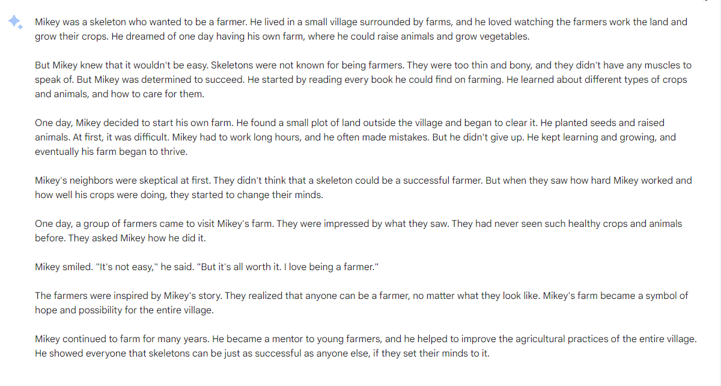However, reading through ChatGPT’s output was far more interesting than its competitor. It has a beginning setting, character interactions, and a clear ending like an actual story. Despite Chat outputting the text line by line and not all at once, like Bard, it utilizing far more resources in order to create a clear and concise story.

